**Module-3**

**CORROSION SCIENCE AND E-WASTE MANAGEMENT**

**Lecture 1**

**Corrosion**

Corrosion is defined as **“the destruction of metals or alloys by the surrounding environment through chemical or electrochemical changes.”**

The process of corrosion is the transformation of pure metal into its undesired metallic compounds. The life of a metal object gets shortened by the corrosion process.

The familiar examples of corrosion are

1. Rusting of iron – a reddish brown scale formation on iron and steel objects. It is due to the formation of hydrated ferric oxide.
2. Green scales formed on copper vessels. It is due to the formation of basic cupric carbonate [CuCO3 + Cu(OH)2].

Effects of Corrosion

* Loss of efficiency.
* Contamination of product.
* Damage of metallic equipment’s.
* Inability to use metallic materials.
* Appearance as when corroded material is unpleasing to the eye.
* Loss of valuable materials such as blockage of pipes, mechanical damage of

underground water pipes.

* Accidents due to mechanical loss of metallic bridges, cars, aircrafts etc.
* Safety, for example, sudden failure can cause fire, explosion, release of toxic product,

and construction collapse.

* Depletion of Natural Resources.
* India Losses 5.7 % GDP due to corrosion.

**Chemical corrosion (Dry corrosion)**

Chemical corrosion occurs due to the direct chemical reaction between the metal and the gases present in the corrosion environment. This type of corrosion is generally observed in the absence of moisture or conducting electrolyte medium. Therefore it is also known as dry corrosion.

Eg: Oxidation of metals or alloys on exposure to oxygen in air.

Reaction of corrosive gases such as HCl, H2S, SO2, Cl2, F2, NH3 etc with metal and alloy surfaces.

**Electrochemical corrosion (Wet corrosion)**

Electrochemical corrosion involves reactions in aqueous medium. The conducting surface of the metal undergoes an electrochemical reaction with the moisture and oxygen present in the atmosphere. This process can be explained on the basis of electrochemical theory of corrosion.

**Electrochemical theory of corrosion**

When a metal, such as iron, is exposed to the environment, according to electrochemical theory the following electrochemical changes occur gradually.

1. Formation of anode and cathodic areas due to the presence of heterogeneities at the interface of the metal and environment corrosion (oxidation) takes place at the anodic area.
2. The electrons released at the anodic area are taken up by the cathodic area.
3. Oxygen of the atmosphere is reduced to OH¯ ions in the presence of water (moisture) at the cathodic area.

**Anodic reaction**:

At the anodic area, oxidation takes place resulting in the corrosion of iron.

Fe  Fe+2 + 2e-

**Cathodic reactions**:

Electrons flow from the anodic to cathodic area and cause reduction depending on the nature of the corrosion environment. Since the metal can not be reduced further, metal atoms at cathodic region are unaffected by the cathodic reaction. Some constituents of the corrosion medium take part in the cathodic reaction.

Most common types of cathodic reactions are either liberation of hydrogen or absorption of oxygen.

1. **Liberation of hydrogen takes place in the absence of oxygen**
2. In acidic medium and in the absence of oxygen, hydrogen liberation takes place.

2H+  + 2e-H2↑

1. In neutral or alkaline medium and in the absence of oxygen, hydroxide ions are formed with liberation of hydrogen.

2H2O + 2e-  2OH¯ + H2↑

1. **Absorption of oxygen takes place in the presence of oxygen.**
2. In acidic medium and in the presence of oxygen.

4H+ + O2 + 4e- 2H2O

(ii) In neutral or alkaline medium and in the presence of oxygen, hydroxide ions are formed

2H2O + O2 + 4e-4OH¯

The metal ions formed at the anode combine with the OH¯ ions and form the insoluble Fe(OH)2. In an oxidizing environment, it is oxidized to ferric oxide and the yellow rust is hydrated ferric oxide.

2Fe+2 + 4OH¯2Fe(OH)2

4Fe(OH)2 + O2 + 2H2O2[Fe2O3·3H2O]

Rust

In the presence of limited oxygen, ferrous hydroxide is converted into magnetic oxide of iron (Fe3O4) and is known as black rust.

3Fe(OH)2 + ½ O2  Fe3O4·3H2O

Black rust

**Review Questions**

1. What is corrosion?

2. Give example for corrosion.

3. What are the ill effects of corrosion?

4. What is chemical corrosion?

5. What is electrochemical corrosion?

6. What is the chemical composition of rust?

**Lecture 2**

**Types of corrosion**

**Differential metal corrosion(Galvanic corrosion)**

Differential metal corrosion occurs when two dissimilar metals are in contact with each other in a corrosive conducting medium. The two metals differ in their tendencies to undergo oxidation, the one with lower electrode potential or the more active metal acts as anode and the one with higher electrode potential acts as cathode. The potential difference between the two metals is the driving force for corrosion. The anodic metal undergoes corrosion and the cathodic metal is generally unattacked.

The following reactions occur during differential metal corrosion.

At the anode : M M+n  + ne-

At the cathode : Depending on the nature of the corrosion environment the cathode reaction is either hydrogen evolution or oxygen absorption.

(i) 2H+ + 2e- H2 (g)

(ii) O2 + 2H2O + 4e- 4OH¯

For example if a piece of iron combined with copper is exposed to corrosive atmosphere. Iron acts as anode in the presence of copper (iron is placed above copper in the electrochemical series). In such case, iron undergoes corrosion and copper is unaffected.

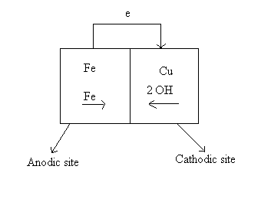

**Differential aeration corrosion**

Differential aeration corrosion occurs when a metal surface is exposed to differential air concentrations or oxygen concentrations, the part of the metal exposed to higher oxygen concentration acts as cathodic region and the part of the metal exposed to lower oxygen concentration acts as anodic region. As a result the part of the metal exposed to lower oxygen concentration undergoes corrosion.

At the anode (less O2 concentration)

M M+n + ne- (oxidation)

At the cathode (more O2 concentration)

O2 + 2H2O + 4e- 4OH¯ (reduction)

“**Corrosion of metals is due to the formation of a oxygen concentration cell because of the uneven supply of air on the metal surface is known as differential aeration corrosion.”**

Examples

1. Part of the nail inside the wall which is exposed to lower oxygen concentration than the exposed part, undergoes corrosion.

ii. Window rods inside the frame suffer corrosion but not the exposed parts.

iii. Metal under dirt, dust, scale or water undergoes corrosion.

iv. Paper pins inside the paper gets corroded, and the exposed part is free from corrosion.

Water line corrosion and pitting corrosion are the two cases of differential aeration corrosion.

**Water line corrosion**

Water line corrosion is observed in steel water tanks, ocean going ships etc.

The water line corrosion takes place due to the formation of differential oxygen concentration cells. The part of the metal below the water line is exposed only to dissolved oxygen while the part of the metal above the water is exposed to higher oxygen concentration of the atmosphere. Thus part of the metal below water acts as anode and undergoes corrosion and the part above the water line is free from corrosion.

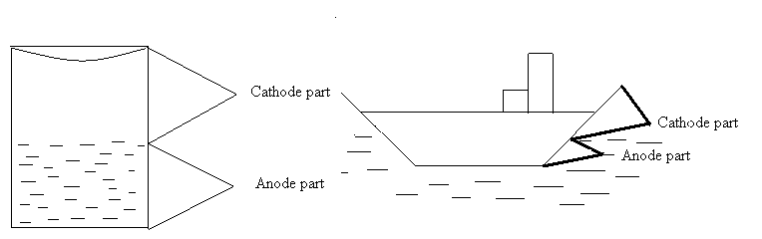

**Review Questions**

1. What is differential metal corrosion?
2. What is differential aeration corrosion?
3. What is waterline corrosion?
4. What is the electrode potential of Iron?
5. What is the electrode potential of Copper?

**Lecture 3**

**Corrosion control**

The methods commonly used to control corrosion of metals are

1. **Protective coatings** i. Inorganic coating ii. Metal coating iii. Organic coating
2. **Cathodic protection**
3. **Anodic protection**
4. **Corrosion inhibitors**

**1. Protective coatings**

The protective coating protects the metal from corrosion by acting as a barrier between the metal and the corrosion environment.

**Inorganic coating**

Inorganic coatings are generally obtained by converting a surface layer of the metal into a compound by chemical or electrochemical reactions, which forms a barrier between the metal surface and the corrosion environment.

**Anodizing**

Anodized coatings are generally produced on non ferrous metals like Al, Zn, Mg and their alloys by anodic oxidation process, in which the base metal is made as anode in an electrolytic bath of suitable composition, and by passing direct electric current. The most commonly used baths are chromic acid, sulphuric acid, phosphoric acid, oxalic acid, boric acid or their mixtures. After anodizing, the oxide coating is sealed by immersing in boiling water.

**Anodizing of Aluminium involves the following steps.**

The article to be anodized is degreased, thoroughly polished, connected to the anode and steel or copper is made as the cathode. The electrolyte is 5-10% chromic acid. The temperature of the bath is maintained at 35ºC. The voltage is programmed to increase from 0 to 50V to maintain an anode current density of 10-20mA/cm2. During the first 10 minutes, the potential is increased from 0 to 40V. When the potential reaches 40V, anodizing is continued for 20 minutes. After 20 minutes the voltage is increased from 40 -50V and held at 50V for five minutes. An opaque oxide layer of 2-8µm thickness is obtained.

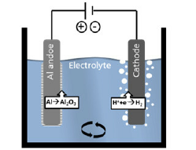

For higher thickness, 10% sulphuric acid is used as an electrolyte at 22ºC. 25µm thick film is obtained using a current density of 160mA/cm2 at 24V.

The article can be coloured by immersing for about 20 minutes in an aqueous solution of the dye stuff at 50-60ºC.

Finally the object is treated with nickel or cobalt acetate followed by boiling water treatment to improve corrosion resistance.

Anodized articles are used as soap boxes, tiffin carriers, window frames etc.

**Metal coating**

Corrosion of metals can be controlled by depositing a protective metal over the surface of a base metal. This process is called metal coating. Metal coating can be anodic metal coating or cathodic metal coating.

**Anodic metal coating**

Anodic coatings are produced by coating a base metal with more active metals which are anodic to the base metal.

For example, iron is coated with more active metals such as zinc, magnesium and aluminium. The characteristic feature of anodic coating is that, the base metal on which coating is done will not get corroded even if the coating is ruptured. The exposed surface of the metal is cathodic with respect to the coating metal and the coating metal undergoes corrosion. Therefore anodic coating is also known as sacrificial coating. Galvanization is an example of anodic metal coating.

**Galvanization**

Galvanization is a process of coating a base metal surface with zinc metal. Galvanization is carried out by hot dipping method. The galvanization process involves the following steps.

1. The metal surface is washed with organic solvents to remove organic matter on the surface.
2. Rust and other deposits are removed by washing with dilute sulfuric acid.
3. Finally the article is washed with water and dried.
4. The article is then dipped in a bath of molten zinc, maintained at 425- 430ºC and covered with a flux of ammonium chloride to prevent the oxidation of molten zinc.
5. 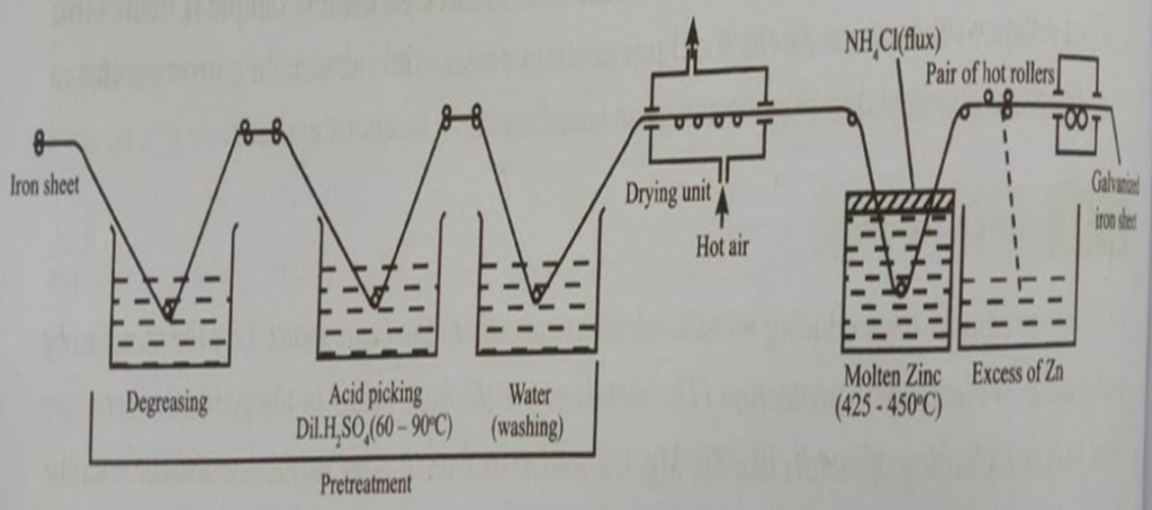The excess zinc on the surface is removed by passing through a pair of hot rollers, which wipes out excess of zinc coating and produces a thin coating.

Galvanized articles are used in the form of roofing sheets, fencing wire, buckets, bolts, nuts, nails, screws, pipes tubes etc.

**Review Questions**

1. What is metal coating?
2. What is protective coating?
3. What is anodizing?
4. What is inorganic coating?
5. What is anodic metal coating?
6. What is galvanization?

**Lecture 4**

**Cathodic protection**

Corrosion of metals occurs because of the flow of electrons from the anodic to cathodic regions. The anodic regions undergo corrosion whereas the cathodic regions are unaffected. The principle of cathodic protection is to reverse this flow of electron. This can be achieved by providing electrons from an external source so that the metal always remains cathodic.

The technique by which metals are protected from corrosion by providing electons from an external source is called cathodic protection.

Cathodic protection can be achieved by the following methods

1. Sacrificial anode method
2. Impressed current method

**Sacrificial anode method**

In this method, the metal to be protected is converted into a cathode by connecting it to a more active metal. This active metal acts as anode. Zinc magnesium and aluminium are the commonly used anodes. These metals, being more active, act as anode and undergo preferential corrosion, protecting the metal structure. Since the anodic metals are sacrificed to protect the metal structure, therefore the method is known as sacrificial anode method. The sacrificial anodes which get corroded in course of time have to be replaced.

Examples

1. A magnesium block connected to a buried oil storage tank. fig(a)
2. Mg bars are fixed to the sides of ocean going ships to act as sacrificial anodes. Fig(b)
3. Zn wire buried along the oil pipeline.

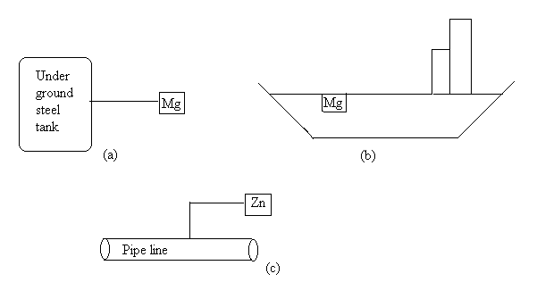

**Review Questions**

1. What is cathodic protection?
2. What sis sacrificial anode method?
3. What are the advantages of sacrificial anode method?
4. What are the disadvantages of sacrificial anode method?

**Lecture 5**

**The corrosion penetration rate (CPR)**

The corrosion penetration rate (CPR) is defined as

**The speed at which any metal in a specific environment deteriorates due to a chemical reaction in the metal when it is exposed to a corrosive environment.**

The speed or rate of deterioration depends on the environmental conditions and the type and condition of the metal under study.

Corrosion penetration rate may also be known as corrosion rate.

Several pieces of data must be collected to calculate the corrosion penetration rate for any given metal:

* The weight lost (the decrease in weight of the metal during the period of reference).
* The density of the metal.
* The total surface area initially present.
* The time taken for the metal to corrode.

**The CPR is calculated as follows:**

CPR = (k x W) / (D x A x T)

where k = a constant

W = total weight lost

T = time taken for the loss of metal

A = the surface area of the exposed metal

D = the metal density in g/cm³

The corrosion penetration rate is best expressed in terms of thickness or weight loss where the surface of the metal corrodes uniformly across an area.

This method involves the exposure of a weighed piece of test metal or alloy to a specific environment for a specific time. This is followed by a thorough cleaning to remove the corrosion products and then determining the weight of the lost metal due to corrosion.

**Review Questions**

1.What is corrosion penetration rate?

**Lecture 6**

**ELECTRODE SYSTEM**

**Electrochemical cells**

A device which converts chemical energy into electrical energy or electrical energy into chemical energy is called electrochemical cell. There are 2 types

1. The one which converts chemical energy into electrical energy is called galvanic cell.
2. The one which converts electrical energy into chemical energy is called electrolytic cell.

An electrochemical cell consists of two electrodes. When the electrodes are connected by a metallic wire, an electric current flow as a result of a spontaneous redox reaction. Each electrode usually consists of a metal in contact with a solution of its own ions. Since a cell is a combination of two electrodes, each electrode is referred to as a single electrode or a half cell.

**Single electrode potential(E)**

When a metal is in contact with a solution of its own ions, the potential developed at the interface between the metal and the solution is called single electrode potential.

**Standard electrode potential(E0)**

The potential developed when the electrode is in contact with a solution of unit concentration at 298K. If the electrode contains gas then its pressure is one atmosphere. It is denoted by E◦.

**Sign conventions**

The electrode potential of an electrode is positive, if the electrode reaction is reduction when coupled with the standard hydrogen electrode and electrode potential is negative if the electrode reaction is oxidation when coupled with the standard hydrogen electrode.

Example

When copper electrode is combined with standard hydrogen electrode, copper electrode acts as cathode and under goes reduction and hydrogen electrode acts as anode.

**H2 2H+  + 2e- (oxidation)**

**Cu+2 + 2e-Cu (reduction)**

Hence electrode potential of copper is assigned a **positive sign**. Its standard electrode potential is **0.34V**.

When zinc is coupled with standard hydrogen electrode, zinc electrode acts as the anode and undergoes oxidation and hydrogen electrode acts as the cathode.

**ZnZn+2 +2e-**

**2H+  + 2e- H2**

Hence the electrode potential of zinc is **negative. It is -0.76V.**

**Cell notation**

If two electrodes are combined to form a cell, then the cell is represented by writing the electrode conventions side by side with anode (negative electrode) on the left and the cathode (positive electrode) on the right. The two electrode representations are separated by a double line. The double line represents the presence of a salt bridge. Hence the cell can be represented as:

**M1|M1+n(C1)||M2+n(C2)|M2**

Eg: Daniell cell can be represented as represented as follows:

**Zn|Zn+2(1M)||Cu+2(1M)|Cu**

**Cell potential or EMF of a cell**

It is the potential difference between two half cells in an electrochemical cell, which causes the flow of current from one electrode (higher potential) to the other (lower potential).

It is denoted by Ecell.

Cell potential is calculated using the formula

**Ecell = ER.H.E – EL.H.E**

**Ecell = Ecathode - Eanode**

By knowing the electrode potentials of the electrodes constituting the cell, the cell potential can be calculated.

**Types of electrodes**

Some of the important types of electrodes are grouped into the following types.

i) *Metal –Metal ion electrode:* where a metal is in contact with its ionic solution.

Eg: Cu+2|Cu, Zn+2|Zn, Ag+|Ag

ii) *Metal- metal salt ion electrode (metal- insoluble salt electrode):* where a metal is in contact with its insoluble salt which is in contact with a solution containing the anion of the salt.

Eg; Calomel electrode.

iii) *Gas electrode:* In this an inert metal such as platinum is in contact with gas molecules and also with the ionic solution of the same gas molecule.

Eg: Standard Hydrogen electrode (SHE).

iv) *Amalgam electrode:* where metal-amalgam is in contact with a solution containing its own metal ions.

Eg: Lead- amalgam electrode (Pb- Hg|Pb+2)

v) *Oxidation- reduction electrode:* An oxidation-reduction electrode is the one in which the electrode potential arises from the presence of oxidized and reduced forms of the same metal substance in solution. The potential developed is picked up by an inert metal like platinum.

Eg: Pt |Fe+2, Fe+3

vi) *Ion selective electrode (Membrane electrode):* This electrode is more selective towards a particular type of ion, in a mixture of ions and used to measure concentration of that particular ion.

Eg; Glass electrode.

**Ion selective electrodes**

“These are the electrodes which can detect a specific ion in a mixture and the potential developed at the electrode is a function of the concentration of that ion in the solution.’’

The electrodes consist of a membrane which is capable of exchanging the specific ions with the solution with which it is in contact.

Ion selective electrodes are also called membrane electrodes. Example for ion selective electrode is glass electrode.

**Glass electrode**

**Principle**: If a thin walled glass bulb containing an acid is immersed in another solution, a potential is developed across the glass membrane. The potential difference Eb at the interface also referred to as the boundary potential. This is due to the difference in potential (E1-E2) developed across the gel layer of the glass membrane between the two liquids.

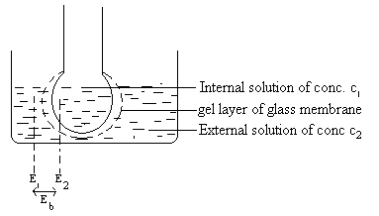

Eb is related to the difference in the hydrogen ion concentration of the two solutions by the relation.

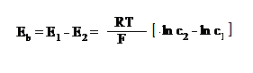

Where C1 is the concentration of H+ ions of the acid solution inside the glass bulb and C2 is the concentration of the acid solution into which glass bulb is dipped.



If the concentration C1 of the solution inside the glass bulb is constant then the first term on RHS of above equation is constant. Therefore



Substituting the value of R and F at 298K



Where L is a constant which depends on the pH of the solution taken in the bulb and in glass electrode assembly. Since C2= [H+] of the solution.

The equation can be written as



**Construction of glass electrode**

A glass electrode consists of long glass tube with a thin walled bulb at one end. Special glass of low melting point and high electrical conductance is used for the purpose. The bulb contains 0.1M HCl and a Ag|AgCl electrode (as an internal reference electrode) is immersed into solution and connected by a platinum wire for electrical contact.the electrode is represented as

Ag|AgCl| 0.1M HCl |glass

The membrane undergoes an ion exchange reaction. The Na+ ions on the glass are exchanged for H+ ions.



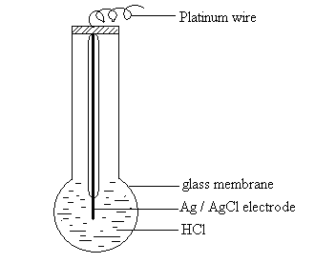

The boundary potential established due to the above reaction is mainly responsible for glass electrode potential EG. The potential of the glass electrode EG is given by

EG = Eb + EAg|AgCl

From equation (1) Eb= 0 when C1=C2. But in practice it has been observed that even when C1=C2 a small potential is developed. This is called asymmetric potential

(Easy). Hence EG can be written as

EG = Eb + EAg|AgCl + Easy

EG = L – 0.0591pH + EAg|AgCl + Easy

or

EG = L1 – 0.0591pH where L1 is a constant equal to L + EAg|AgCl + Easy

**Review Questions**

1. Ion Selective electrodes is also known as?

2. Give an example for metal-metal ion electrode.

3. What is the internal reference electrode in glass electrode known as?

4. What is an electrochemical cell?

5. Give an example for metal-metal salt ion electrode.

6. Give example for gas electrode.

**Lecture 7**

**Determination of pH using Glass Electrode**

To determine the pH of a given solution the glass electrode is dipped in a solution whose pH need to be determined. It is combined with a saturated calomel electrode which is a reference electrode.



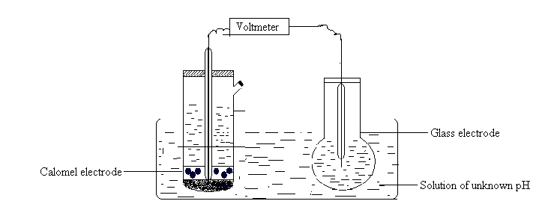

The emf of the so formed cell is determined potentiometrically.

Ecell = EG - Ecal

Ecell = L1 – 0.0591pH -Ecal

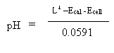

L1 value is determined by dipping the glass electrode in a solution of known pH and measuring the emf of the cell formed when combined with a calomel electrode.

**Reference Electrodes**

*Reference electrodes are the electrodes whose potentials are known and with reference to those, the electrode potentials of other electrodes are measured.*

Eg: Standard hydrogen electrode is the primary reference electrode as the electrode potentials of other electrodes are assigned with respect to it.

Because of the difficulties involved in the use of standard hydrogen electrode as primary reference electrode some other electrodes of constant electrode potential, referred to as secondary reference electrodes are employed as reference electrodes.

Two such electrodes which are in common use are calomel electrode and silver-silver chloride electrode.

**Calomel Electrode**

The calomel electrode consists of mercury, mercurous chloride (Hg2Cl2) and a solution of KCl. Mercury is placed at the bottom of a glass tube. Mercury is covered by a paste of mercurous chloride (calomel) with mercury and potassium chloride solution. A solution of KCl is introduced above the paste through the side tube. A platinum wire sealed into a glass tube is dipped into mercury and used to provide the external electrical contact. The concentration of KCl solution used is either decinormal, normal or saturated. Correspondingly the electrode is known as decinormal, normal or saturated calomel electrode respectively.

The calomel electrode is represented as **Hg| Hg2Cl2| Cl-**

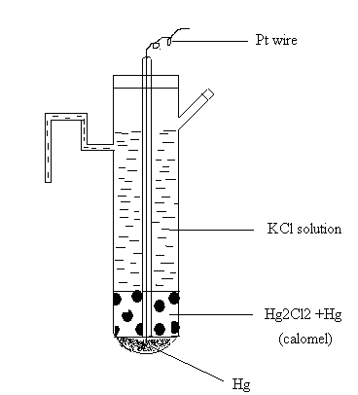

Depending upon the nature of the other electrode of the cell, the calomel electrode can act as anode or cathode.

When it acts as anode the electrode reaction is

**2Hg Hg2+2 + 2e-**

**Hg2+2 +2Cl-Hg2Cl2**

**2Hg +2Cl- Hg2Cl2 +2e-**

When it acts as cathode, the electrode reaction is

**Hg2+2 + 2e-2Hg**

**Hg2Cl2  Hg2+2 +2Cl-**

**Hg2Cl2 +2e-2Hg + 2Cl-**

The net electrode reaction is

**Hg2Cl2 +2e- 2Hg + 2Cl-**





The electrode potential depends on the concentration of the chloride ions.

At 298K, the electrode potentials are as follows

0.1N KCl electrode (0.334V) and Saturated KCl electrode (0.2422V)

**Applications:**

* It is used as a secondary reference electrode in the measurement of single electrode potential.
* It is the most commonly used reference electrode for potential measurement.

**Measurement of single electrode potential using secondary reference electrode (calomel electrode)**

The test electrode (eg: Zn|Zn+2) is coupled with a secondary reference electrode for example saturated calomel electrode. It is represented as Zn|Zn+2||Cl-|Hg2Cl2|Hg

The emf of the cell is determined experimentally by potentiometric method then

Ecell = Ecathode – Eanode

Ecell = Ecal – EZn

Ecell = 0.2422 – EZn ie EZn = 0.2422 – Ecell

**Concentration Cells**

Galvanic cells in which both the anode and the cathode are made up of the same element (metal or non-metal) in contact with the solutions of the same electrolyte, but emf arises due to difference in concentrations of electrolyte are referred to as concentration cells.

Eg: Concentration cell consisting of two half cells. Both the electrodes are made up of copper metal but dipped in copper sulphate solutions of different concentrations. It is represented as

**Cu|Cu+2(C1)||Cu+2(C2)|Cu**

Where C1and C2 are the molar concentrations of the Cu+2 ions in the two half cells.

By convention left hand electrode is the anode and the right-hand electrode is the cathode. The half-cell reactions are

**Cu  Cu+2(C1) + 2e- (Anode reaction)**

**Cu+2(C2) + 2e-Cu (Cathode reaction)**

Adding the two half-cell reactions, the net cell reaction is

**Cu+2(C2) Cu+2(C1)**

The potential of the cell is Ecell= ER -EL



Where E◦ is the standard reduction potential of the species in the concentration cell. On simplifying



Ecell is positive if C2>C1

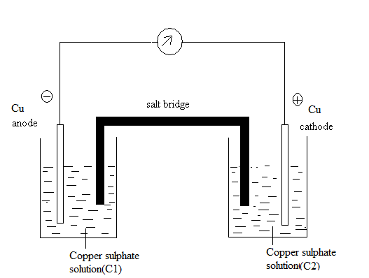

In a concentration cell the electrode with lower electrolyte concentration acts as the anode and the one with higher electrolyte concentration acts as the cathode.

**Review Questions**

1. Give an example for reference electrode.

2. What is concentration cell?

3. Give the application of calomel electrode.

4. What is half-cell?

**Lecture 8**

**Analytical Techniques**

Analytical chemistry methods refer to techniques used for the detection, identification, characterization, and quantification of chemical compounds.Qualitative identifies analytes, while [quantitative analysis](https://en.wikipedia.org/wiki/Quantitative_analysis_(chemistry)) determines the numerical amount or concentration. Several Instruments and sensors are being used for analysis as these methods are faster, accurate and require a minimum quantity for analysis. Instrumental methods such as conductometry and potentiometry are some examples of these methods.

**CONDUCTOMETRY**

**Principle/ Theory**

Conductometric titrations are the titrations in which amount of the analyte present in the given solution is measured by the change in conductance. The principle underlying in conductometry is the measurement of replacement of ions of a particular conductivity by ions of different conductivity during a chemical reaction. Conductivity electrodes or sensors are used to determine the end point in acid base titrations. Neutralization point is determined by observing the change in specific conductance of the solution. Specific conductance(K) is the conductance of a solution present between 2 parallel electrodes of area 1cm2 which are kept 1cm apart. Here R is the resistance.



The specific conductance of an electrolytic solution at any temperature depends on ions present and hence varies with ionic concentration. The measurement of conductance is used to determine the equivalence point in acid base titrations. In conductometric titration, there is a sudden change in conductance of solution at equivalence point. Hence equivalence point is determined by plotting a graph of conductance versus volume. Therefore, concentration of the analyte in the solution can be calculated.

**Instrumentation**

Conductometer consists of 2 platinum electrodes and a conductance measuring device. The 2 electrodes have unit area of cross section and are placed unit distance apart. The solution to be estimated is taken in a beaker. The system responds readily to changes in concentration of analyte.



**Advantages**

* Mixture of acids can be titrated accurately.
* Accurate results are obtained in dilute as well as more concentrated solutions.
* The method can be employed for colored solutions also.

**APPLICATION:**

**Estimation of Weak Acid**

**Titration of weak acid with a strong base:** (CH3COOH Vs. NaOH)

The conductance of weak acid, acetic acid is initially low, due to poor dissociation. When a strong base is added, the salt is formed, gets ionized and conductance increases slowly. After the complete neutralization, further addition of base NaOH introduces more and more Na+ and OH- ions into the solution, conductance again increases rapidly. When conductance of the solution is plotted against volume of base added, two straight lines are obtained. The point of intersection corresponds to the volume of base required to neutralize weak acid.

**CH3COOH + NaOH → CH3COONa + H2O**

The plot of conductance versus volume of strong base is as follows.



**Procedure**

Fill the microburrete with standard NaOH solution. Pipette out the given weak acid into clean 100 cm3 beaker. Immerse the conductivity cell connected to conductivity meter in acid *(CH3COOH)* given. Add 0.5 cm3of the NaOH solution from the burette. Stir the solution gently and measure the conductance. Continue the measurement of conductance after each addition of 0.5 cm3 of NaOH solution. The titration should be continued till the slow increase in conductance changes to sudden increases near equivalence point; and at least 5-6 readings should be taken after that. Plot a graph of conductance on y- axis versus volume of NaOH on x -axis. The volume corresponding intersection of two lines is the neutralization point of Acetic acid.

**POTENTIOMETRY**

**Principle**

In potentiometric titrations, concentrations of the solutions can be calculated by measuring the emf between two electrodes dipped in the analyte solution.

The potential of an electrode is given by Nernst equation,



i.e. The potential of an electrode depends on concentration of ion to which it is reversible. This method can be used in the determination of end points of acid-base titrations, red-ox titrations etc. When a known volume of analyte is titrated with a standard solution, neutralization or red-ox reaction takes place. During the course of titration, concentration of product will be continuously altered. If a metal electrode, reversible with respect to corresponding ions is placed in the solution, the potential will vary throughout the titration, which can be determined using a suitable device. Initially, the change in potential is very small. At the equivalence point, when the amount of titrant added is equivalent to the amount of analyte present, there will be a sharp rise in potential. Beyond the equivalence point, there will be no significant change in potential. By plotting a graph of change in potential against the volume of titrant added, the equivalence point can be determined.

**Instrumentation**

Potentiometer consists of a reference electrode, an indicator electrode, and a potential measuring device. The indicator electrode responds to the changes in concentration of analyte. A reference electrode like saturated calomel electrode is also used. A known volume of analyte is taken in the beaker and its potential is determined. The titrant is added in increments of 0.5 ml and emf is measured each time. At equivalence point, emf increases rapidly. At this point, titrant is added in small increments of 0.5ml. a few readings are taken beyond the end point. Thus, the changes in potential at different volumes of titrant are recorded.



**ADVANTAGES:**

* Potentiometric titrations can be carried out in colored solutions where indicators cannot be used.
* By potentiometry, it is possible to determine the end point in titrations of redox, precipitation and acid-base titrations.

**APPLICATION:**

**Estimation of Iron (Fe) using acidified Potassium dichromate solution**

Potentiometry can be used to determine the end point of a redox titrations by measuring the change in potential during titration using a platinum-calomel electrode combination.

The titrations involving Mohr's salt solution and Potassium dichromate solution can be done by Potentiometry.

* The platinum electrode is used as an indicator electrode and coupled with a calomel electrode (reference electrode) and dipped in a solution of known volume of analyte (Mohr's salt solution) and connected to potentiometer and emf is measured.
* The titrant (Potassium dichromate) of known concentration is added in increments of 0.5ml from burette to the analyte solution and emf is measured each time after stirring the solution.
* FAS reacts with K2Cr2O7 under acidic conditions, the redox electrode potential is set up at indicator electrode. Pt/Fe2+,Fe3+.
* The electrode potential of the redox electrode is given by Nernst equation

C:\Users\PC\Desktop\g.PNG

* The electrode potential depends upon concentration of Fe2+ and Fe3+,
* As the titration proceeds Fe3+ increases and Fe2+decreases and redox electrode potential increases and emf of the cell goes on increasing and steep rise is seen at equivalence point.
* At equivalence point all the Fe2+is converted to Fe3+ions and redox potential of Pt/Fe2+,Fe3+ stops and further addition of dichromate new redox potential comes into existence Pt/Cr6+,Cr3+ because the solution contains Cr3+ions produced due to reduction of dichromate by Fe2+ ions. This redox electrode Pt/Cr6+,Cr3+ has higher potential than Pt/Fe2+,Fe3+.
* Plot a graph of ΔE/ ΔV versus volume of K2Cr2O7  gives the equivalent point.

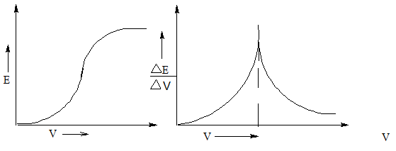

**Review Questions**

1. What is the oxidation state of iron on FAS?

2. What is the oxidation state of Chromium in Potassium dichromate?

3. Name the electrodes used in Potentiometry.

4. Name the electrodes used in Conductometry.

5. Which are the acids present in acid mixture in conductometric tritration?

6. What are the applications of Conductometric titrations?

7. What are the applications of Potentiomertic metric titrations?

**Lecture 9**

Tutorial -1

Numerical problems on CPR.

**Lecture10**

Tutorial -2

Numerical problems on Concentration cells.

*****************************************************************

**Question Bank on Corrosion, Electrode System & Analytical techniques**

1. Explain the electrochemical theory of rusting of iron.
2. Define cathodic protection. Explain the sacrificial anode technique for prevention of corrosion.
3. Explain Differential metal corrosion.
4. Explain differential aeration corrosion with suitable examples.
5. Explain pitting and waterline corrosion with examples.
6. What is corrosion? Explain the rusting of iron based on electrochemical theory.
7. What is anodizing? Explain anodizing of aluminium.
8. What are reference electrodes? Explain construction, working and application of calomel electrode.
9. What is ion selective electrodes? Discuss construction, working and application of glass electrode.
10. Write a note on type of electrodes.
11. Explain the theory and instrumentation of Potentiometry
12. Explain the theory and instrumentation of Conductometry
13. Explain the application of Conductometry in estimation of weak acid.
14. Explain the application of Potentiometry in estimation of Fe.
15. Write a note on concentration cells.
16. Explain the determination of pH using glass electrode.

***Dr. Lavanya D. Kateel***

***Department of Science & Humanities***

***CEC***